**A CROSS-CULTURAL PERSPECTIVE FOR PERSONALIZING PICTURE PASSWORDS**

**by**

***SAYYAPPARAJU ANIL VARMA 411768***

***KOMPELLA VENKATA SUBRAHMANYA VEDESH 411733***

***KAKILETI SRI VENKATA MANIKANTA 411728***

***Under the guidance of***

**Dr. Goutham Reddy**



**DEPARTMENT OF COMPUTER SCIENCE AND ENGINEERING**

**NATIONAL INSTITUTE OF TECHNOLOGY, ANDHRA PRADESH**

**TADEPALLIGUDEM-534102, INDIA**

**APRIL - 2021**

**A CROSS-CULTURAL PERSPECTIVE FOR PERSONALIZING PICTURE PASSWORDS**

***Thesis submitted to***

***National Institute of Technology Andhra Pradesh***

***for the award of the degree***

***of***

***Bachelor of Technology***

***by***

***SAYYAPPARAJU ANIL VARMA 411768***

***KOMPELLA VENKATA SUBRAHMANYA VEDESH 411733***

***KAKILETI SRI VENKATA MANIKANTA 411728***

***Under the guidance of***

**Dr. Goutham Reddy**



**DEPARTMENT OF COMPUTER SCIENCE AND ENGINEERING**

**NATIONAL INSTITUTE OF TECHNOLOGY ANDHRA PRADESH**

**TADEPALLIGUDEM-534102, INDIA**

**APRIL - 2021**

© 2018. All rights reserved to NIT Andhra Pradesh

**DECLARATION**

I declare that this written submission represents my ideas in my own words and where others' ideas or words have been included, I have adequately cited and referenced the original sources. I also declare that I have adhered to all principles of academic honesty and integrity and have not misrepresented or fabricated or falsified any idea/data/fact/source in my submission. I understand that any violation of the above will be cause for disciplinary action by the Institute and can also evoke penal action from the sources which have thus not been properly cited or from whom proper permission has not been taken when needed.

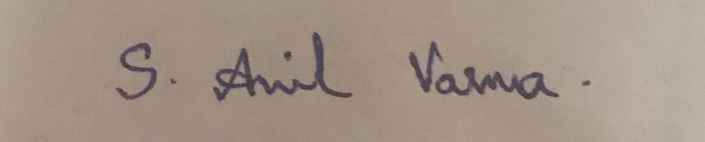  

| (Signature) | (Signature) | (Signature) |
| --- | --- | --- |
| Sayyaparaju Anil Varma | Kompella Venkata Subrahmanya Vedesh | Kakileti Sri Venkata Manikanta |
| 411768 | 411733 | 411728 |
| Date: 26-04-2021 | Date: 26-04-2021 | Date: 26-04-2021 |

**CERTIFICATE**

It is certified that the work contained in the thesis titled “**A Cross-Cultural Perspective For Personalizing Picture Passwords**” by “Sayyaparaju Anil Varma, bearing Roll No:411768, Kompella Venkata Subrahmanya Vedesh, bearing Roll No:411733, Kakileti Sri Venkata Manikanta, bearing Roll No:411728” has been carried out under my/our supervision and that this work has not been submitted elsewhere for a degree*

**Signature of Supervisor(s)**

**Dr. A. Goutham Reddy Department of Computer Science and Engineering**

**N.I.T. Andhra Pradesh**

**April, 2021**

*Note: this statement is mandatory

**ACKNOWLEDGEMENT**

The success and outcome of this project required a lot of guidance and assistance from many people, and we are privileged to have got this all along with the completion of our project. Everything we have done is because of such guidance and help, and we will never hesitate to thank them.

We owe our sincere gratitude to our project guide Dr A. Goutham Reddy, Department of Computer Science, National Institute of Technology, Andhra Pradesh, who took keen interest and guided us all along, till the completion of our project work by providing all the necessary information.

We are grateful and lucky enough to receive consistent motivation, support, and guidance from all the staff of the Computer Science Department. They have helped us to complete our project work successfully. We would also like to extend our sincere gratitude to all my friends for their timely support.

  

| **Sayyaparaju Anil Varma** | **Kompella Venkata Subrahmanya Vedesh** | **Kakileti Sri Venkata Manikanta** |
| --- | --- | --- |

**LIST OF FIGURES**

| **Figure** | **Title** | **Page No** |
| --- | --- | --- |
| **1** | Interaction effect between culture group and picture type on the time spent to explore picture | **6** |
| **2** | Generated images by taking users opinions | **10** |
| **3** | Partitioned image which was selected by the user | **11** |

**LIST OF TABLES**

| **Table No** | **Title** | **Page No** |
| --- | --- | --- |
| **1** | Summarization of the main results. | **7** |

**LIST OF ABBREVIATIONS**

**HTML** : Hypertext Markup Language

**PHP** : Hypertext Preprocessor

**MySQL** : My Structured Query Language

**ABSTRACT**

Picture passwords are one of the most secure and easiest ways of authentication. In general, picture passwords require users to draw selections on images as their secret password, by providing pictures without considering that people across various cultures exhibit differences in different aspects.

People from different cultures exhibit differences in visual processing, comprehension and exploration of the picture content prior to making their password selections. Also, it aids them to remember it for a long time. Hence there is a need to consider cultural differences in the design of personalized picture passwords in order to have a better trade-off between security and usability.

Hence our system generates images based on the user's interests thereby allowing the user to select images whatever he wants.

**TABLE OF CONTENTS**

|  | | Page No |
| --- | --- | --- |
| Title | | i |
| Declaration | | iii |
| Certificate | | iv |
| Acknowledgements | | v |
| List of Figures | | vi |
| List of Tables | | vi |
| List of Symbols and Abbreviations | | vi |
| Abstract | | vii |
| Table of Contents | | viii |
| Contents | |  |
| 1 | Chapter 1 | 1 |
|  | 1.1 Introduction | 1 |
|  | 1.2 Picture superiority effect | 1 |
| 2 | Chapter 2 | 3 |
|  | 2.1 Problem statement | 3 |
| 3 | Chapter 3 | 4 |
|  | 3.1 Literature review | 4 |
|  | 3.1.1 Cultural preferences of people across the world | 4 |
|  | 3.1.2 Preference of users to have cultural aspects | 4 |
|  | 3.1.3 Support to design | 5 |
| 4 | Chapter-4 | 8 |
|  | 4.1 Proposed Architecture | 8 |
|  | 4.1.1 Aim | 8 |
|  | 4.1.2 Approach | 8 |
|  | 4.2 Images Generation | 8 |
|  | 4.2.1 Aim  4.2.2 Approach | 8  9 |
|  | 4.3 Slicing and Setup password | 9 |
|  | 4.3.1 Aim | 9 |
|  | 4.3.2 Approach | 9 |
|  | 4.4 Authenticating User | 9 |
|  | 4.4.1 Aim | 9 |
|  | 4.4.2 Approach | 9 |
| 5 | Experimental Procedure | 10 |
|  | 5.1 Experimental Procedure | 10 |
| 6 | Results and Discussion | 12 |
| 9 | Conclusions and Future Scope | 13 |
|  | References | 14 |
|  |  |  |

**CHAPTER 1**

**1.1 Introduction**

Authentication is an important security task in order to protect the sensitive information from attackers. Text-based passwords require users to memorize a sequence of alphanumeric characters. But memorizing strong text-based passwords results in increased load on the user, which often leads to poor usability and limited security. Hence to offer a better trade-off between security and usability, various picture password schemes have been proposed over the years, which require users to complete a picture-based task to authenticate.

One of the important aspects affecting security and usability of the picture password scheme is the background pictures on which the user sets the password. Picture perception is important for the authentication task, as users are requested to recall from memory the previously selected password selections in order to authenticate. The task of creating a picture password is a perceptual process through the human visual system, and involves steps like initial impression of the input stimuli, information processing and output response. Hence when a user sets a password on the image which is known to him, then there are better chances of memorizing and the user also sets a strong password which in turn increases security. However many picture password designs provide the same kind of predetermined images to the users which may lead to poor security as well as usability.

**1.2 Picture superiority effect:**

The picture superiority effect refers to the phenomenon where people remember pictures better than they remember the corresponding words. In other words, pictures are superior over words when it comes to recalling and recognizing information. Our goal is to strengthen authentication by taking advantage of graphical password authentication methods.

Hence to overcome the limitations of these picture password schemes , our system generates images based on the user’s culture so that the user can create a strong password thereby enhancing security and usability.

**CHAPTER 2**

**2.1. Problem Statement**

**Problem 1:** The main intuition behind our project is to provide more familiar pictures to the users to make their task of remembering password easy. Hence we should not compromise in user convenience. We cannot assure that the images produced by us will be taken by the users. We have to handle this problem.

**Approach 1:** Based on the user’s interest we will generate images. If a user is interested in those images, it’s fine, else we are providing an option to upload user interested images. This assures user satisfaction.

**Problem 2:** In the second phase of the authentication process, we are asking users to tap parts of the selected image to enter. But there is a chance of shoulder attack. We have to take sufficient precaution.

**Approach 2:** We are rotating the plane of the sectioned image plane entirely. It will make it difficult to identify the tapped images. We are avoiding patterns as it is prone to attacks and compromise users while selecting interested parts.

**Problem 3:** There is a chance that the user may forget the password. In that case we have to provide a mechanism to recover his account. Security questions can be used, but that are prone to guessing attacks as we generate images based on the user's culture. Hence an attacker can guess the answers based on the images he sees. So, we need to protect against these attacks.

**Approach 3:** We are asking the user to upload an image of his own interest and set a password for it so that this can be used at the time of account recovery process.

**CHAPTER 3**

**3.1. Literature Review**

In this section, we present prior research that is directly relevant to user memory on picture recognition and remembering as well as textual and graphical passwords.

**3.1.1. Cultural preferences of people across the world:**  Preferences of people are impacted by their culture. This statement is supported by the following literature survey. The Norenzayan et al. [1] investigated the way European Americans, Asian Americans, and East Asians categorize objects. Participants were presented with two groups of objects and were then asked to determine the group to which each target picture was most similar. The results were like this, the holistic preference of Asian Americans and East Asians who judged similarity based on family culture, compared to the European Americans who relied on the unidimensional rule while deciding whether the target object shared a single feature with all the members of a category or not. The studies also revealed that the user’s cultural background can influence processes such as attention and memory [2, 3, 4, 5]. A study in [6] suggested that Japanese attend more to the “whole” compared to North Americans who attend more to specific features of stimulus. Participants were initially presented with a square frame that contained a vertical line, and were then engaged in a framed-line test that assessed their abilities to draw the line in either absolute length or proportional to the height of the surrounding empty frame. Results revealed that individuals in Asian cultures are more capable of incorporating contextual information, while individuals in North American cultures are more capable of ignoring contextual information. To examine the influence of culture in recalling details from memory, a study in [7] revealed that Americans were more accurate than East Asians in memorizing specific features for objects presented alone and within a context supporting that analytic preference of Western cultures can account for the increased specificity of visual information retained in memory [8]. These studies show how cultural aspects influence people as well as how they aid users to remember them.

**3.1.2. Preference of users to have cultural aspects:** Users are interested in having their cultural aspects in the web pages or tasks that they do. The following studies will explain the above statement. From a usability and personalization perspective, prior works suggest that incorporating cultural aspects in the design of interactive schemes can improve effectiveness, efficiency and users’ experience [9-11]. For instance, a cross-cultural study conducted by Singh et al. [11] revealed users’ preference on websites adapted to their local culture. Also, recent works [12,13] have shown that cultural differences impact the way people across cultures perceive, respond and interact with persuasive systems. Orji et al. [12] investigated the influence of the determinants on healthy eating behavior and found that eating behaviors and practices are often determined by cultural and social factors. Hence, they proposed culturally relevant design approaches for bootstrapping persuasive technology interventions by considering the effects of culture. Oyibo et al. [14] examined the determinants of physical activity and found differences across diverse cultures. In particular, the individualist culture was more effective in promoting behavior change through self-motivating strategies, whereas the collectivist culture was more effective through socially oriented strategies. Accordingly, the authors provided a set of design guidelines for applications that tailor the persuasion strategies by considering individuals’ culture, and this is how culture impact persons in different ways and makes them to grab attention towards their culture related aspects. So, providing culture-based images will make users satisfied as well as memorize the password strongly.

**3.1.3 Support to design:** According to studies humans have an exceptional ability to recognize images previously seen, even when the images are viewed very briefly due to the picture superiority effect. Picture superiority effect refers to the phenomenon that for the human brain, recognition is an easier memory task than recall, and due to this it is easier for humans to recall graphical information as compared to textual information. The most widely recognized explanation for the picture superiority effect is the dual coding theory. According to the dual-coding theory, graphical images are encoded in the human brain not only visually, but the images are also converted into a verbal form and remembered semantically. Biddle leveraged this phenomenon of human memory more effectively retrieving images than textual description to develop various recognition-based graphical passwords schemes. This supports our idea of using graphical authentication. Moreover, users’ cultural background, knowledge, expertise and experience impact the perceived affordance of the various interface elements [15, 16]. From a memorability perspective, works in [17, 18] suggested the feasibility of using autobiographical memories to query users about their daily experiences for the task of user authentication. A cross-cultural study in [19] supports a positive effect on memorability of graphical passwords that consist of images relevant to users’ culture. Also, recent literature has shown a positive main effect of users’ real-life memories towards memorability of user-generated passwords [20]. From a security perspective, evidence suggests that the design of security systems should take into consideration the social and cultural contexts of the end-users (e.g., marital status, indigenous populations) in order to facilitate their needs (e.g., trust in a relationship, limited banking services) [21, 22]. However, it is important to control which sociocultural aspects, and to what extent, are incorporated in the design of security systems to avoid educated guessing attacks [23].The discussed works provide evidence that individuals’ cultural differences: i) determine the inherited way of receiving, processing, and interpreting visual stimulus which is a cornerstone factor in picture password schemes [24]; and ii) influence usability [15-18, 9-13] and security [21-23] of user authentication schemes. However, to the best of the authors’ knowledge, there is a lack of knowledge related to the effects of cultural differences with respect to password creation, memorability, and security within picture password schemes. They suggest that investigating these effects will allow us to better consider such differences in the design of personalized user authentication schemes. For doing so, they conducted a cross-cultural study (Eastern vs. Western) in which users interacted with a picture password scheme using culture-internal vs culture-external pictures in the context of a real-life task. The following graphs show behavior of different culture people.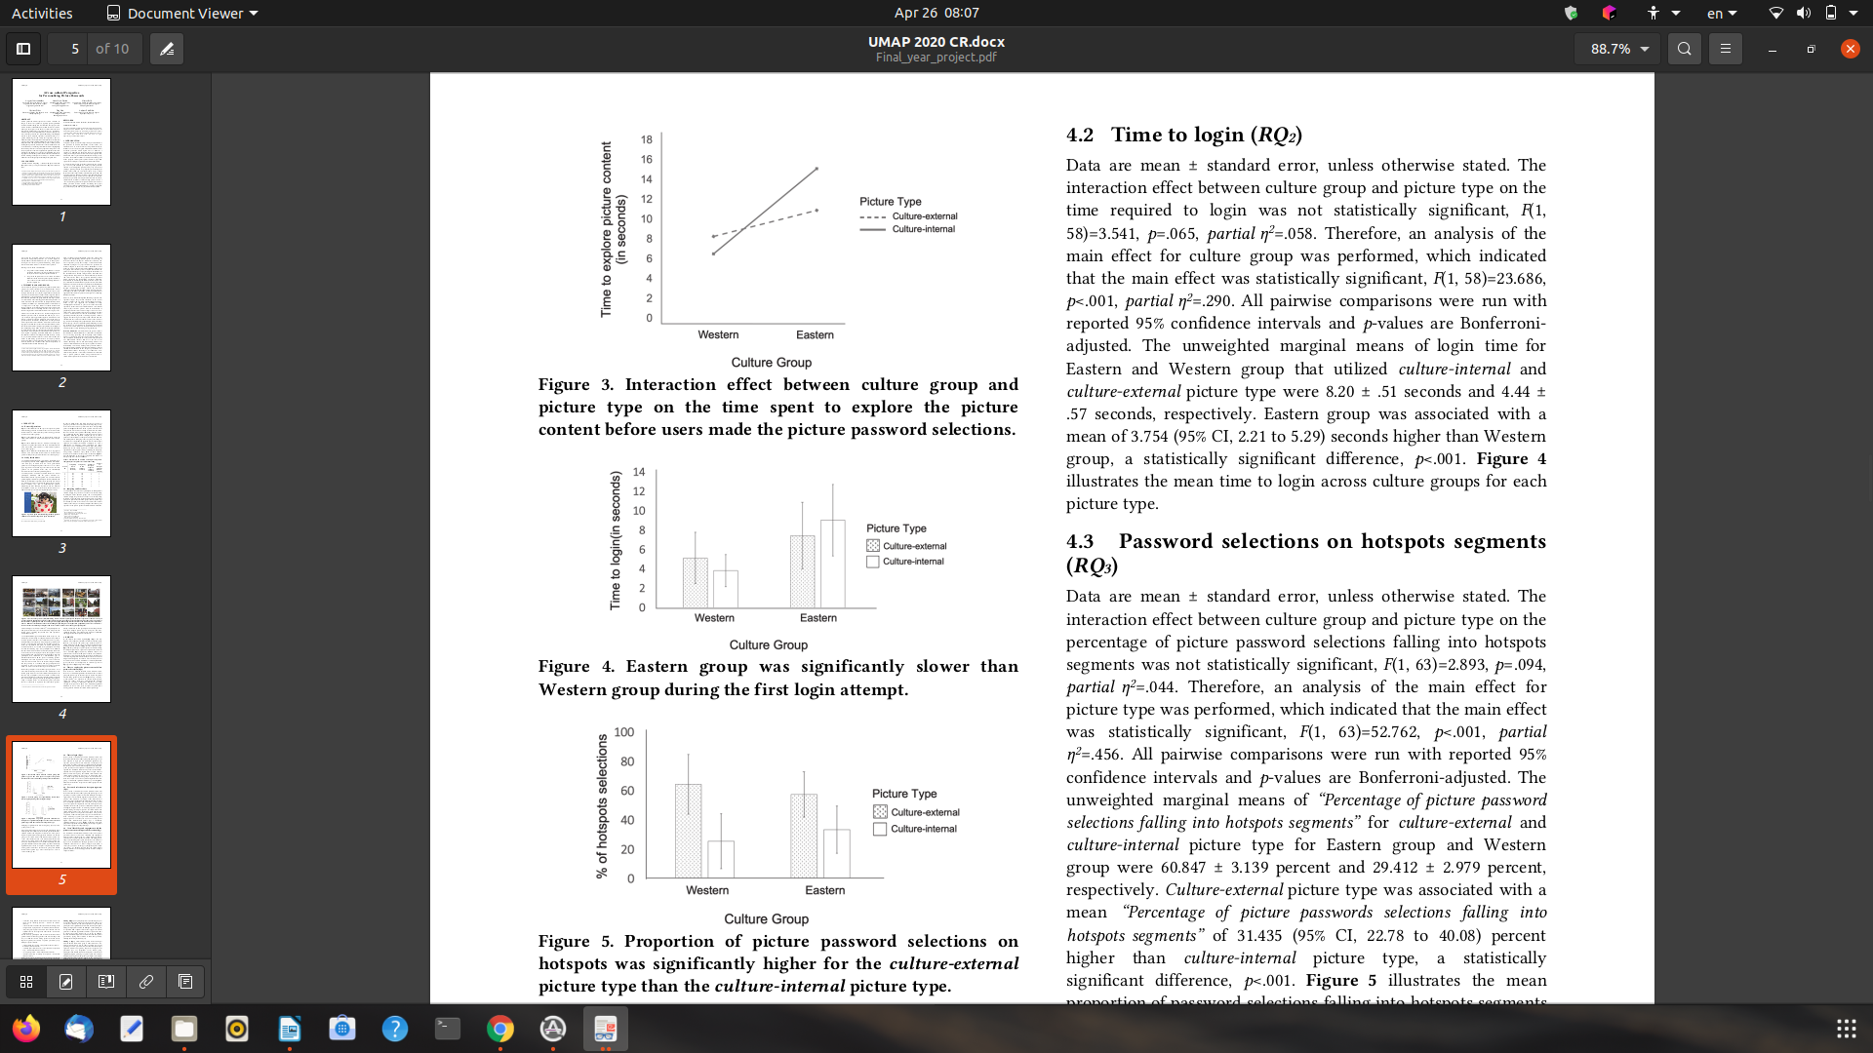

**Figure 1. Interaction effect between culture group and picture type on the time spent to explore the picture content before users made the picture password selections.**

The following table shows the metrics of different cultural people.

**Table 1. Summarization of the main results.**

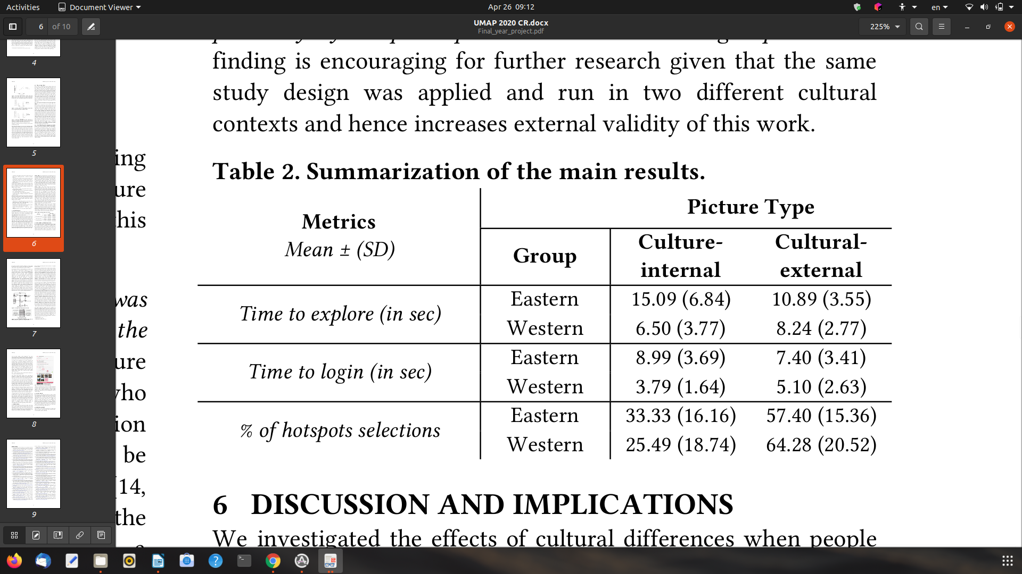

**CHAPTER 4**

**PROPOSED APPROACH**

We present the design and working methodology of the proposed CROSS-CULTURAL PERSPECTIVE FOR PERSONALIZING PICTURE PASSWORDS authentication. This proposed approach is efficient and offers secure authentication, which also addresses various security threats. In the next chapter, we will discuss the detailed implementation of this framework.

**4.1. Proposed Architecture**

**4.1.1. Aim**

Architecture to authenticate users using efficient and secure graphical authentication methods by taking users cultural interests.

**4.1.2. Approach**

Initially the user enters into the entrance page. Thereby we ask the user whether he is a new user or already registered user. If the user is a new user, then he has to enter a signup page to enter his details, else he will directly go into the login page. To facilitate this, our approach is to create a web page which provides signup and login buttons. After entering the sign-up page we provide a form which consists of text fields to enter username, and some questions to generate candidate pictures. To preserve users' privacy, we are informing users about the data that we are going to take from them in the form of questionnaires. We also ask the user to upload a picture of his own choice and set up a pin with which he is familiar in order to use this during the forgot password step.

**4.2. Images Generation**

**4.2.1. Aim**

To generate images based on users input as well as external images which are out of their culture.

**4.2.2. Approach**

Here our approach is to create a web page consisting of 9 images in which some are generated based on the user’s interest and some are out of culture. Then the user has to select only one of the displayed pictures. If he is not interested in the displayed pictures, our approach is to facilitate the user to upload a picture of his own choice, which will increase user’s satisfaction.

**4.3. Slicing and Setup of password**

**4.3.1. Aim**

To facilitate users to create their pin type password and thereby successfully storing it into the database.

**4.3.2. Approach**

Here our approach is to create a web page consisting 9 parts partitioned image which was selected by the user. We ask users to tap on the parts to set a password. This password will be stored in the database.

**4.4. Authenticating User:**

**4.4.1. Aim**

To authenticate users based on their previously selected password and an option to utilize forgot password if the user forgets the password.

**4.4.2. Approach**

Here our approach is to create a HTML web page consisting 9 parts partitioned image which was selected by the user. We ask users to tap on the parts to get authenticated. If he forgets the password, we allow him to use the forgot password option.

**EXPERIMENTAL PROCEDURE**

**5.1. Experimental Procedure**

In this chapter, we present the procedure and implementation of the proposed approach.

The implementation starts with the user proceeding to login if he is already a registered user or signup if he is yet to register.

If the user proceeds to sign up, he is redirected to a new page where the user types his desired username and is assigned that username if that username is unique by searching from our database. After assigning the username, the user is supposed to fill in the form which has different types of questions and the user selects his desired questions and answers them. Then after submitting the form, the user is redirected to a page where there are images based on his responses (culture-internal) from the form as well as the images which are external to his culture.

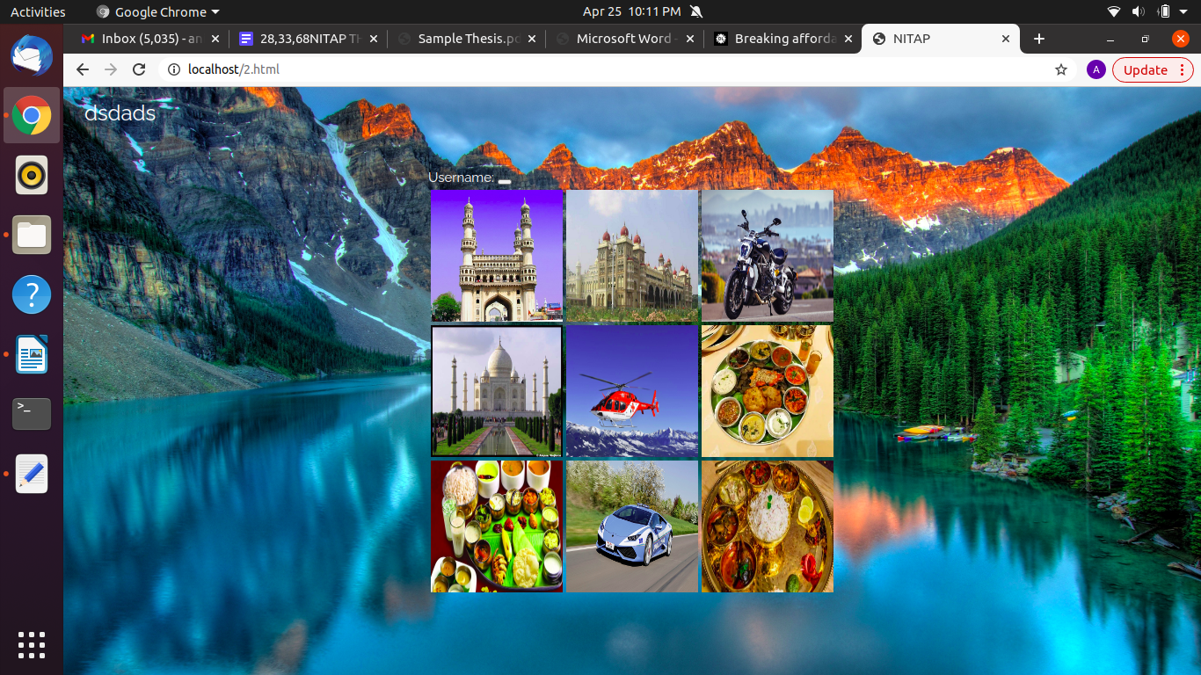

**Figure 2. Generated images by taking users opinions**

The user then selects an image of his choice from the set if he wishes to, or else he is allowed to upload an image of his choice if he is uncomfortable with the image set. After selecting the image, the user is redirected to a page where the image is in segmented form and the user has to set a password by tapping on different segments of the image.

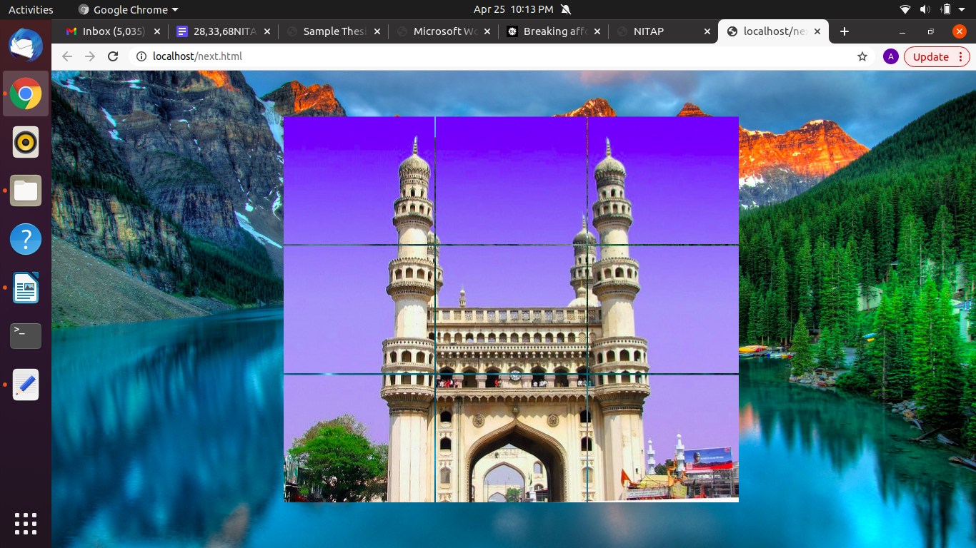

**Figure 3. Partitioned image which was selected by the user**

After setting password, the user is asked to reenter the password to confirm it. Then the user is redirected to a page where the user is asked to upload an image and set a password so that this can be useful for account recovery in case of user forgetting the password. After this step, the Signup process is successfully completed and the details of the user i.e., Username, Sign-in image, Sign-in picture password, Forgot password image and forgot password picture password are stored in the database using PHP and MYSQL.

In the login phase, the user enters the username and then his password image along with some other random images are displayed. Then the user has to select the correct image and then the correct picture password of it in order to successfully login.

In case if the user forgets the password, then after entering the username, the user is given a set of images including his selected image and then the user has to select the correct image and then the correct picture password for the account recovery process.

**RESULTS AND DISCUSSION**

We have seen that the mechanism proposed here for user authentication is effective and user satisfactory. Here, we try to answer the responsiveness of the system to get an idea of the efficiency of the system.

We investigated the effects of cultural differences when people interact with culture-internal vs. culture-external pictures within picture password schemes. Our findings revealed differences in the perceptual processes employed by the Eastern and Western population during picture password creation and login.

To prevent any privacy violations, the Individual Sociocultural Experience Model will provide transparency to the users by notifying them about what personal information the model will be using (e.g., location), what it will be using it for (e.g., for providing pictures relevant to their sociocultural activities during password reset), and it will acquire such information only if it entails location-specific information aligned to the users’ approved privacy model.

Here we also provided the user to upload a picture of his own choice, which will promise user satisfaction. Also we are using highly secured and interesting user pictures while forgetting the password phase.

**CONCLUSION AND FUTURE SCOPE**

This work shows the effect of culture on users interactions within the picture password schemes. It also shows the importance of considering cultural aspects while designing picture password systems.Hence displaying images based on culture for setting the picture password will increase user satisfaction and decrease the chance of forgetting password as it is highly related to the users personal interest which inturn increases the security of the system as the user can set strong password.

Future works may include collection of huge data among all cultures. It is possible because we can use huge API s to generate images, and we can also include some other techniques like facial recognition or fingerprint authentication as their usage has been increasing rapidly.

**REFERENCES**

**[**1] Ara Norenzayan, Edward E. Smith, Beom Jun Kim, and Richard E. Nisbett. 2002. Cultural preferences for formal versus intuitive reasoning. Cognitive science 26, no. 5 (2002): 653-684. DOI:<https://doi.org/10.1207/s15516709cog2605_4>

[2] Angela H. Gutchess and Allie Indeck. 2009. Cultural influences on memory. Progress in brain research, 178, 137-150.

DOI:<https://doi.org/10.1016/S0079-6123(09)17809-3>

[3] Takahiko Masuda and Richard E. Nisbett. 2001. Attending holistically versus analytically: Comparing the context sensitivity of Japanese and Americans. Journal of personality and social psychology, 81(5), 922-934.

DOI:<https://doi.org/10.1037/0022-3514.81.5.922>

[4] Fred C. J. Stevens, Charles D. Kaplan, Rudolph W. H. M. Ponds, Joseph P. M. Diederiks, and Jellemer Jolles. 1999. How ageing and social factors affect memory. Age and ageing, 28(4), 379-384.

DOI:<https://doi.org/10.1093/ageing/28.4.379>

[5] Barbara Rogoff and Jayanthi Mistry. 1985. Memory development in cultural context. In Cognitive Learning and Memory in Children. Springer. DOI:<https://doi.org/10.1007/978-1-4613-9544-7_4>

[6] Shinobu Kitayama, Sean Duffy, Tadashi Kawamura, and Jeff T. Larsen. 2003. Perceiving an object and its context in different cultures: A cultural look at new look. Psychological science 14, no. 3 (2003): 201-206.

DOI:<https://doi.org/10.1111/1467-9280.02432>

[7] Peter R. Millar, Sarah J. Serbun, Akash Vadalia, and Angela H. Gutchess. 2013. Cross-cultural differences in memory specificity. Culture and Brain, 1(2-4), 138-157. DOI:<https://doi.org/10.1007/s40167-013-0011-3>

[8] Richard E. Nisbett and Takahiko Masuda. 2003. Culture and point of view. Proceedings of the National Academy of Sciences, 100(19), 11163-11170. DOI:<https://doi.org/10.1073/pnas.1934527100>

[9] Rilla Khaled, Ronald Fischer, James Noble, and Robert Biddle. 2008. A qualitative study of culture and persuasion in a smoking cessation game. In International Conference on Persuasive Technology (pp. 224-236). Springer, Heidelberg. DOI:<https://doi.org/10.1007/978-3-540-68504-3_20>

[10] Hiroaki Kimura and Tatsuo Nakajima. 2011. Designing Persuasive Applications to Motivate Sustainable Behavior in Collectivist Cultures. PsychNology Journal, 9(1), 7-28.

[11] Nitish Singh, Georg Fassott, Hongxin Zhao, and Paul D. Boughton. 2006. A cross‐cultural analysis of German, Chinese and Indian consumers' perception of web site adaptation. Journal of Consumer Behaviour, 5(1), 56-68.

DOI:<https://doi.org/10.1002/cb.43>

[12] Rita Orji and Regan L. Mandryk. 2014. Developing culturally relevant design guidelines for encouraging healthy eating behavior. Int. J. Hum.-Comput. Stud. 72, 2 (February 2014), 207–223.

DOI:<https://doi.org/10.1016/j.ijhcs.2013.08.012>

[13] Kiemute Oyibo, Rita Orji, and Julita Vassileva. 2017. The Influence of Culture in the Effect of Age and Gender on Social Influence in Persuasive Technology. In Adjunct Publication of the 25th Conference on User Modeling, Adaptation and Personalization (UMAP ’17). ACM, 47–52. DOI:<https://doi.org/10.1145/3099023.3099071>

[14] Kiemute Oyibo, Rita Orji, and Julita Vassileva. 2018. Developing Culturally Relevant Design Guidelines for Encouraging Physical Activity: a Social Cognitive Theory Perspective. Journal of Healthcare Informatics Research, 2(4), 319-352. DOI:<https://doi.org/10.1007/s41666-018-0026-9>

[15] Lidia Oshlyansky, Harold Thimbleby, and Paul Cairns. 2004. Breaking affordance: culture as context. In Proceedings of the third Nordic conference on Human-computer interaction (NordiCHI ’04). ACM, 81–84.

DOI:<https://doi.org/10.1145/1028014.1028025>

[16] Vanessa Evers, Agnes Kukulska-Hulme, and Ann Jones. 1999. Cross-cultural understanding of interface design: A cross-cultural analysis of icon recognition. In Proceedings of the International Workshop on Internationalisation of Products and Systems. IWIPS 1999.

[17] Ann Nosseir, Richard Connor, and Mark Dunlop. 2005. Internet authentication based on personal history—A feasibility test. In Proceedings of Customer Focused Mobile Services Workshop at WWW2005. ACM.

[18]Sauvik Das, Eiji Hayashi, and Jason I. Hong. 2013. Exploring capturable everyday memory for autobiographical authentication. In Proceedings of the 2013 ACM international joint conference on Pervasive and ubiquitous computing (UbiComp ’13). ACM, 211–220. DOI:<https://doi.org/10.1145/2493432.2493453>

[19] Hani Moaiteq Aljahdali and Ron Poet. 2013. The Affect of Familiarity on the Usability of Recognition-Based Graphical Passwords: Cross Cultural Study between Saudi Arabia and the United Kingdom. In Proceedings of the 2013 12th IEEE International Conference on Trust, Security and Privacy in Computing and Communications (TRUSTCOM ’13). IEEE, 1528–1534.

DOI:<https://doi.org/10.1109/TrustCom.2013.187>

[20] Simon S. Woo, Ron Artstein, Elsi Kaiser, Xiao Le, and Jelena Mirkovic. 2019. Using Episodic Memory for User Authentication. ACM Trans. Priv. Secur. 22, 2, Article 11 (April 2019), 34 pages.

DOI:<https://doi.org/10.1145/3308992>

[21] Supriya Singh, Anuja Cabraal, Catherine Demosthenous, Gunela Astbrink, and Michele Furlong. 2007. Password sharing: implications for security design based on social practice. In Proceedings of the SIGCHI Conference on Human Factors in Computing Systems (CHI ’07). ACM, 895–904.

DOI:<https://doi.org/10.1145/1240624.1240759>

[22] Supriya Singh, Anuja Cabraal, Catherine Demosthenous, Gunela Astbrink, and Michele Furlong. 2007. Security design based on social and cultural practice: sharing of passwords. In International Conference on Usability and Internationalization, Springer, 476-485. DOI:<https://doi.org/10.1007/978-3-540-73289-1_55>

[23] Hani Moaiteq Aljahdali and Ron Poet. 2014. Educated Guessing Attacks on Culturally Familiar Graphical Passwords Using Personal Information on Social Networks. In Proceedings of the 7th International Conference on Security of Information and Networks (SIN ’14). ACM,

272–278.

DOI:<https://doi.org/10.1145/2659651.2659727>

[24] Robert Biddle, Sonia Chiasson, and Paul C. van Oorschot. 2012. Graphical passwords: learning from the first twelve years. ACM Comput. Surv. 44, 4, Article 19 (September 2012), 41 pages.

DOI:<https://doi.org/10.1145/2333112.2333114>

[25] Rilla Khaled, Ronald Fischer, James Noble, and Robert Biddle. 2008. A qualitative study of culture and persuasion in a smoking cessation game. In International Conference on Persuasive Technology (pp. 224-236). Springer, Heidelberg. DOI:<https://doi.org/10.1007/978-3-540-68504-3_20>